CS 1010 Project1 – Play Ball!


25 Points
Due: 9/21 @ 11:30 Take me out to the ball game!

Propose:
In this project, you will write a complete Python program. This project will help you to practice use of variables, arithmetic operation and output in a Python program.

Instructions:
- To speed up the process, follow these steps.
  - Download the ###lastnameproj1.py and ###lastnameproj1.docx onto your desktop (use your class code for ### and your last name)
  - Launch Pyscripter and open the .py file from within Pyscripter.

- Add your class code and name to the comments at the top as following:
#Name : ###YourLastNames

- This Python program will complete the following program description
You are asked to write a program to calculate the revenue made from a softball game. The user will input how many tickets sold for each section of seats. Your program will then calculate and display the results below. The stadium has three sections, tickets for section A price is $15.75, section B price is $12.75, and section C price is $9.75. The proceeds will be the sum of the tickets sold. The Expenses is 7% of the Proceeds. You will use UPPERCASE symbolic identifiers for the three prices and the expense rate.

- Write the code:
- You must initialize all variables needed.
- Complete the input section (input tickets for sections A, B and C…one for each section)
- Complete the processing section (calculate the sales for each section, the proceeds, the expenses and then the profits)
- Add the output statement (see screen shot below)
      - Use format for display two digits (see output below.)

5. Select Run | Run to execute your project
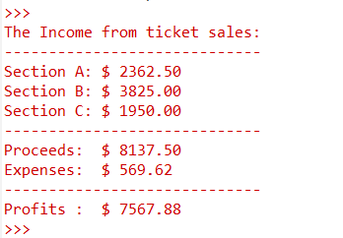
Input: Enter Section A Ticket Sales: 150 Output:
Enter Section B Ticket Sales: 300
Enter Section C Ticket Sales: 200

6. Open the renamed ###lastnameproj1.docx file and copy your output into the file using the snipping tool
- if you can’t see the entire output, drag the code window up by clicking on the dots in the middle(see lab1)

7. Upload your files unto canvas (DO NOT ZIP)
a. Save and close everything
b. Open your mybgsu portal and navigate to your cs1010 class on canvas
c. Click on the Assignment tab and then the project1 link.
d. Select the upload option and upload your both files.

Grade Sheet

CS1010 Project 1: Play Ball!

Name ______________________________________

Project turned in:

(2) Python file named correctly and turned in correctly (your own class code and last name)

(2) Output file named correctly (your own class code and last name)

Coding standards:

(2) Descriptive variable names

(2) In-line comments complete (Initialization Section, Input Section, etc)

Coding:

(3) Initialization Section

(3) Input Section

(3) Calculation Section

(3) Output Section

Program execution:

(5) Project outputs correct results

(25 maximum) Total Points

